L.V. Gromashevsky Institute of Epidemiology and Infectious Diseases National Academy of Medical Science of Ukraine
National Influenza Center

Weekly Bulletin for Influenza Epidemic Situation in Ukraine by 4 Sentinel Centers
(Кyiv, Dnipropetrovsk, Odessa, Khmelnitsky)
Week 8, 2016

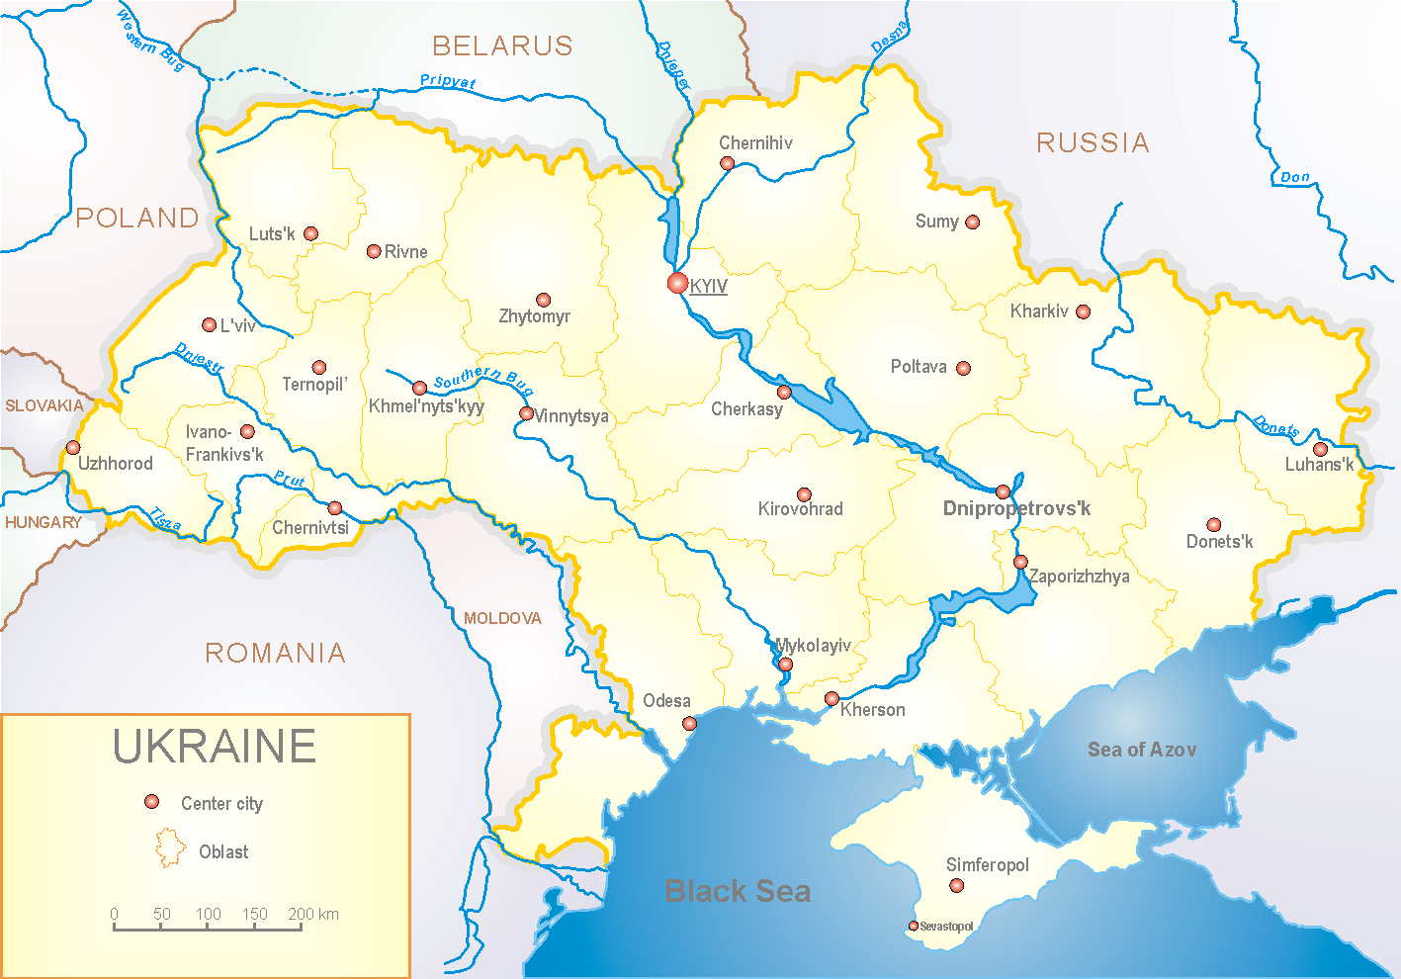
Since 2008 the system of ILI and SARI sentinel surveillance has been functioning in Ukraine. The sentinel centers are located in different geographical areas of the country: in Kyiv, Dnipropetrovsk, Odessa and Khmelnytskyi, which include 18 sentinel stations: 10 hospitals and 8 polyclinics.

According to data of sentinel surveillance system in 8 policlinics of 4 sentinel cities of Ukraine the quantity of outpatient, which meet the definition of ILI during the 8th week (22.02 - 28.02.16) was 101 cases (48.7 per 100 thousand) corresponding population. In comparison with previous week the decline rate of morbidity was 37.0% (fig. 1).

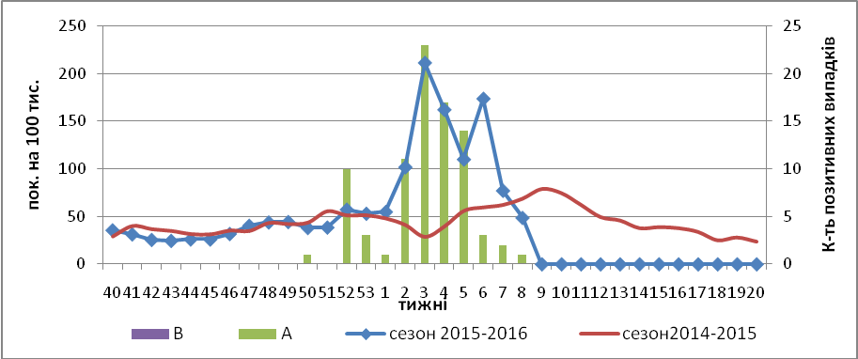

Fig.1. Dynamic of ILI cases and number of laboratory confirmed influenza cases in 4 sentinel cities of Ukraine in the 2015 – 2016 season.

During the 8th week in 10 hospitals of 4 sentinel cities there were hospitalized 1259 patients, this is 7.0% less than during the previous week. The quantity of SARI patients (patients which meet the definition SARI) was 170 cases (5.72 per 100 thousand); the decline rate of morbidity was 17.5% in comparison with the previous week (fig. 2 – 4).

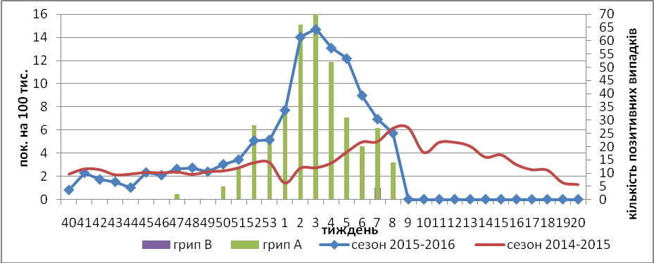

Fig.2. The dynamic of SARI cases and the number of laboratory confirmed influenza in season 2015 – 2016 in four sentinel cities of Ukraine.

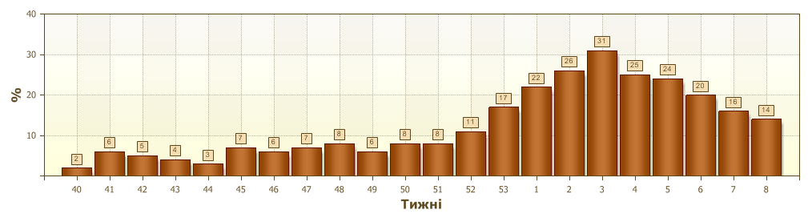
Fig.3. Proportion of SARI from the total number of hospitalizations in 4 sentinel cities of Ukraine in 2015 – 2016 season.

From the beginning of epidemic season among SARI patients there were laboratory confirmed 276 cases of influenza A(H1)pdm, 14 cases – influenza A(H3) and 1 case – influenza B.
During the above mentioned period in sentinel hospitals there were registered 12 laboratory confirmed fatal cases: 5 cases in age group 0-5, 1 case – age group 15-17 and 6 cases in age group 30-64.

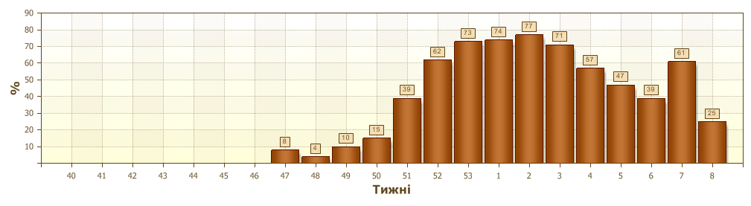
Fig.4. Proportion of laboratory confirmed influenza from all SARI examined in hospitals of 4 sentinel cities of Ukraine in 2015 – 2016 season.

From 40th to 8th week of 2015 – 2016 there were investigated 1274 samples from ILI and SARI patients by PCR method. There were detected 484 (38.1%) positive influenza samples: 342 – influenza viruses A(H1)pdm, 126 – influenza A (unsubtyped) and 15 – A(H3), 1 – influenza B.
From the beginning of epidemic season there were isolated 135 influenza viruses on MDCK cell culture.

Performed by:
Alla Mironenko, MD, DSc
Olga Holubka, PhD.

