L.V. Gromashevsky Institute of Epidemiology and Infectious Diseases National Academy of Medical Science of Ukraine

Scientific Influenza and ARI Center

Weekly Bulletin for Influenza Epidemic Situation in Ukraine by 4 Sentinel Centers
(Кyiv, Dnipro, Odessa, Khmelnitsky)
Week 8, 2020

Loaded on website www.ukrinfluenza.com.ua

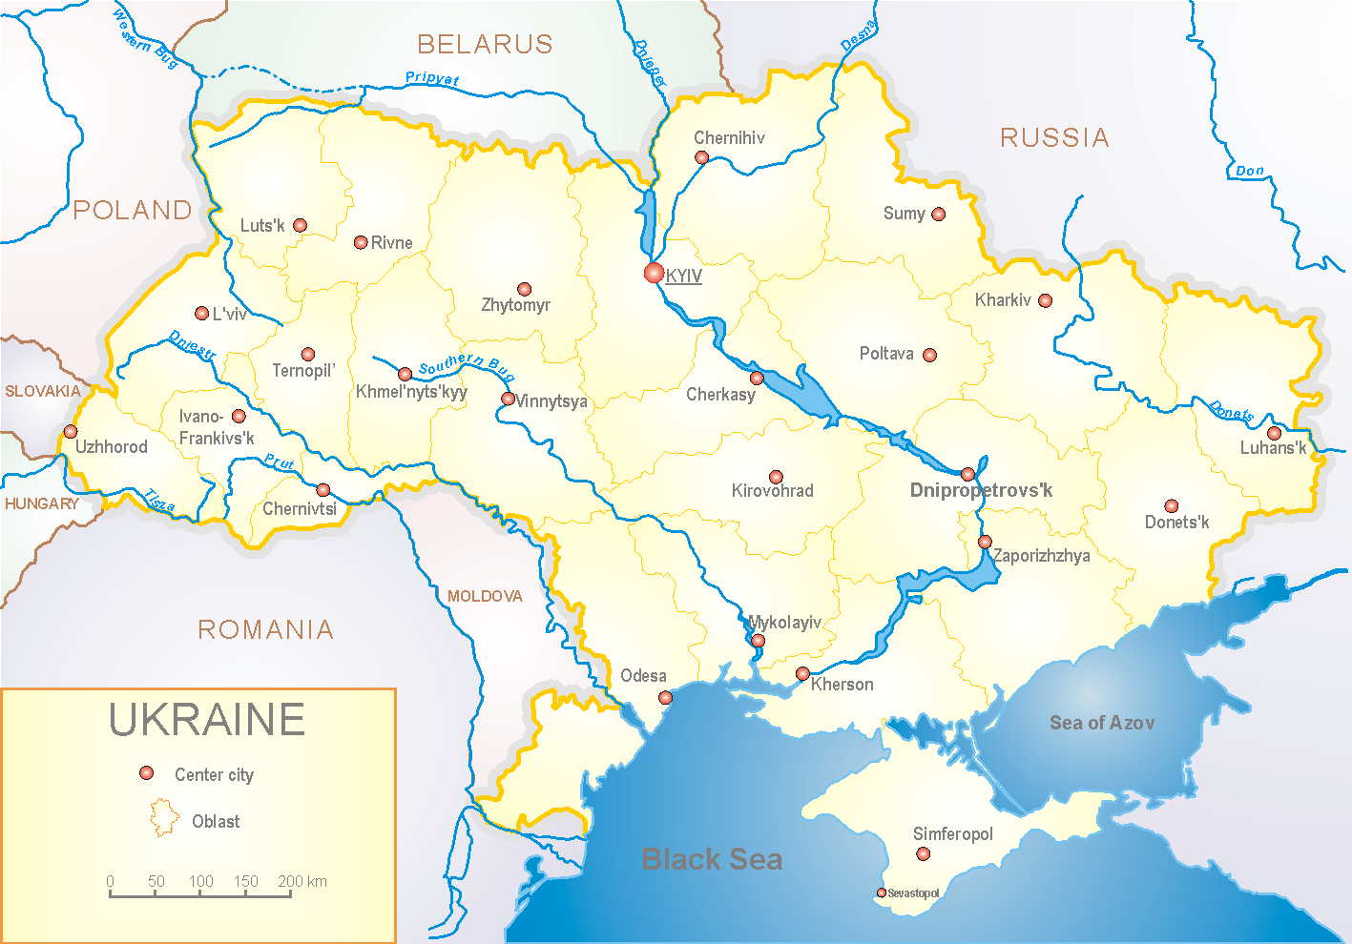
Since 2008 the system of ILI and SARI sentinel surveillance has been functioning in Ukraine. The sentinel centers are located in different geographical areas of the country: in Kyiv, Dnipro, Odessa and Khmelnytsky, which include 18 sentinel stations: 10 hospitals and 8 polyclinics.

According to data of influenza sentinel surveillance system in Ukraine in 8 policlinics of 4 sentinel cities of Ukraine the quantity of outpatient, which meet the definition of ILI during the 8th week (17.02. – 23.02.2020) was 138 cases (13.1 per 100 thousand). The decrease of morbidity level was 22.5%. 1 influenza A(H1)pdm virus was laboratory confirmed (fig. 1).

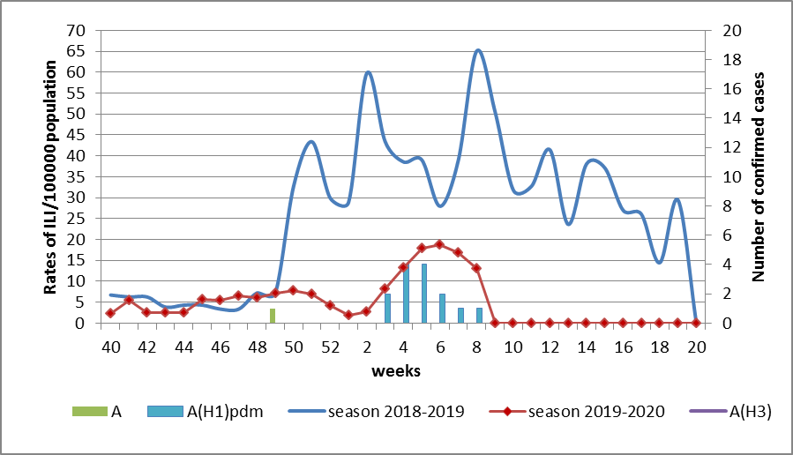

Fig.1. The dynamic of recorded ILI cases and number of laboratory confirmed influenza cases in 4 sentinel centers of Ukraine in the 2019 – 2020 season.

During the 8th week in 10 hospitals of 4 sentinel centers there were hospitalized 1201 patients. This is 3.5% less than during the previous week. The quantity of SARI patients (patients which meet the definition SARI) was 160 cases (6.28 per 100 thousand). There were laboratory confirmed 7 influenza viruses A(H1)pdm and 8 influenza viruses A (unsubtyped) (fig. 2).

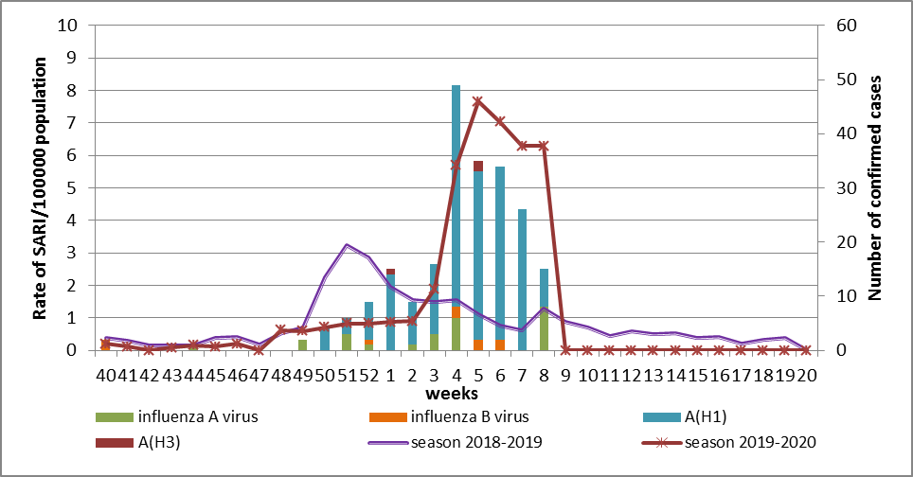
Fig.2 The dynamic of recorded SARI cases and the number of laboratory confirmed influenza in season 2019 – 2020 in four sentinel centers of Ukraine.

Proportion of SARI from the total number of hospitalizations is 13.5% (fig. 3).

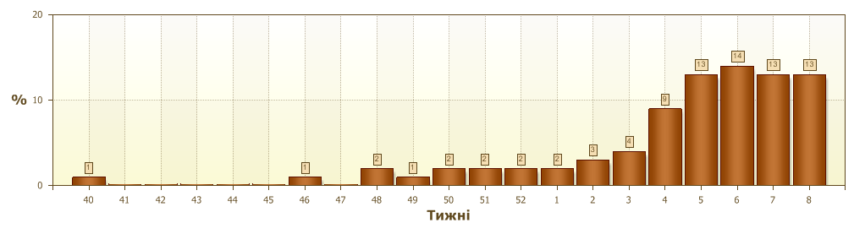
Fig. 3 Proportion of SARI from the total number of hospitalizations.

From the 40th to the 8th week of 2019-2020 season there were investigated 368 samples from ILI and SARI patients by PCR method. There were laboratory confirmed 254 (69.02%) influenza viruses: 27 (10.6%) – influenza A (unsubtyped), 217 (85.4%) – influenza A(H1)pdm, 2 (0.8%) – influenza A(H3), 8 (3.2%) – influenza B (6 – influenza B/Victoria) (fig. 4).

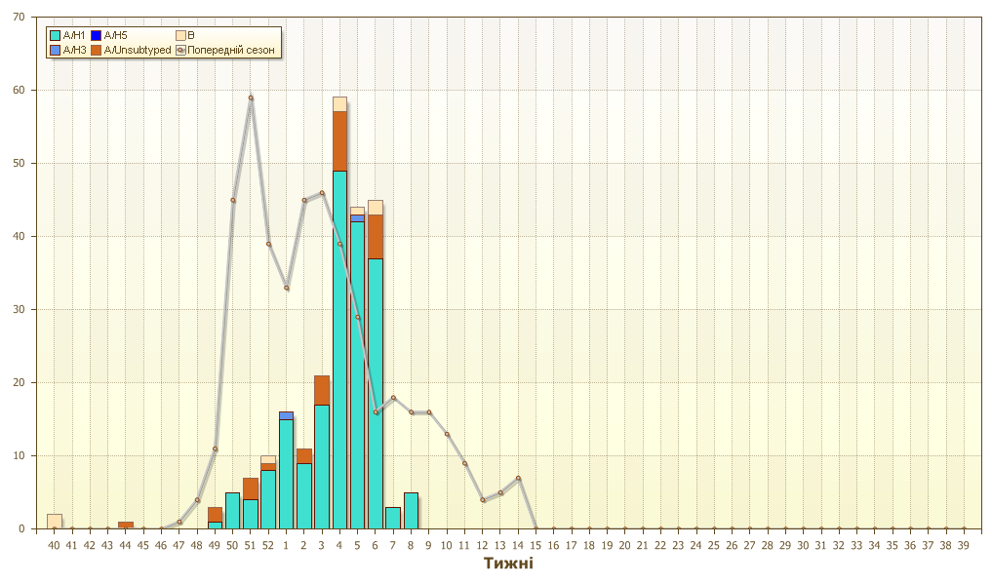
Fig.4. Number of laboratory confirmed influenza positive cases in sentinel centers of Ukraine.
So, we can observe a little decline of ILI and SARI morbidity levels in comparison with the previous week. The highest percent of laboratory confirmed influenza cases is registered among children from 0 to 15 years old (74.0%). Influenza A(H1)pdm (85.4%) predominates among the circulating viruses. Three fatal cases were registered in sentinel hospitals during this flu season. One of them is in age group ˃5 in Dnipro, 1 - in age group 30-64 in Odessa and the other is in the age group 65+ in Kyiv.
According to data of ECDC-WHO weekly bulletin rates of influenza morbidity are at a background level in European countries. The peak of morbidity was during the 5th week of 2020, and the highest percentage (˃ 50.0 %) of positive cases was registered during the 4th week. This completely matches epidemic situation in Ukraine. Influenza virus A(H1)pdm is confirmed in most samples (˃ 60.0 %) from patients with severe flu.

Performed by:
Alla Mironenko, MD, DSc
Olga Holubka, PhD

