L.V. Gromashevsky Institute of Epidemiology and Infectious Diseases National Academy of Medical Science of Ukraine

Scientific Influenza and ARI Center

Weekly Bulletin for Influenza Epidemic Situation in Ukraine by 4 Sentinel Centers
(Кyiv, Dnipro, Odessa, Khmelnitsky)
Weeks 8, 2019

Loaded on website www.ukrinfluenza.com.ua

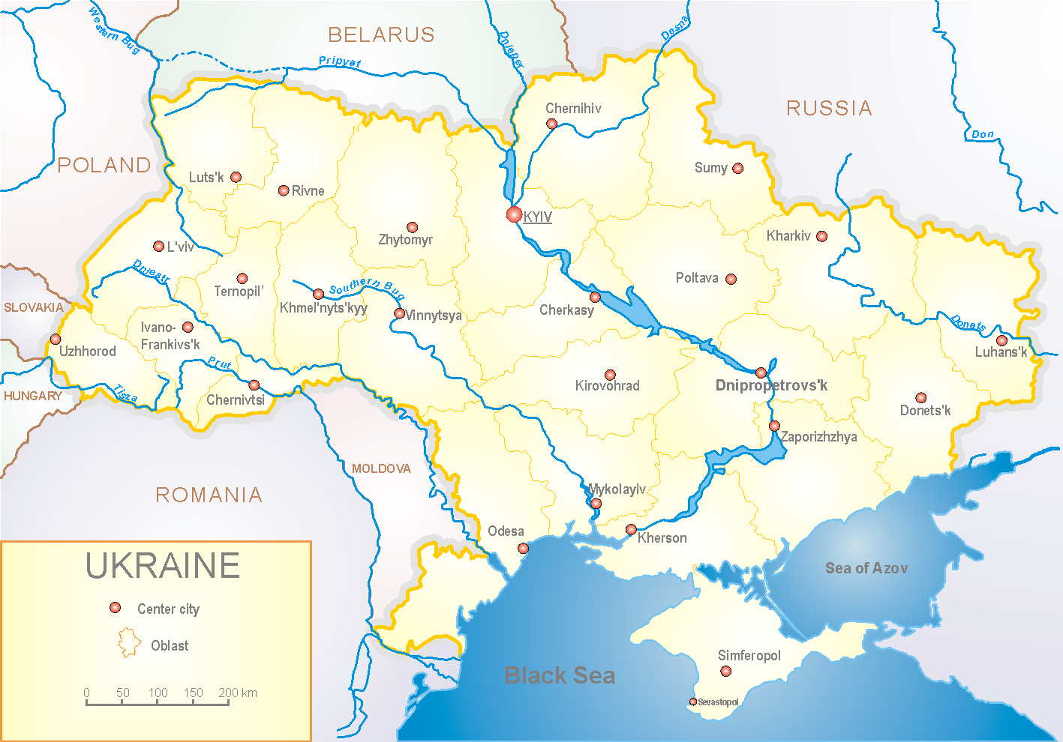
Since 2008 the system of ILI and SARI sentinel surveillance has been functioning in Ukraine. The sentinel centers are located in different geographical areas of the country: in Kyiv, Dnipro, Odessa and Khmelnytsky, which include 18 sentinel stations: 10 hospitals and 8 polyclinics.

According to data of influenza sentinel surveillance system in Ukraine in 8 policlinics of 4 sentinel centers the quantity of outpatients, which meet the definition of ILI during the 8th week (18.02.19 – 24.02.19) was 135 cases (65.1 per 100 thousand). The increase of morbidity level was 66.7%. Laboratory confirmed 1 influenza A(H1)pdm virus (fig 1).

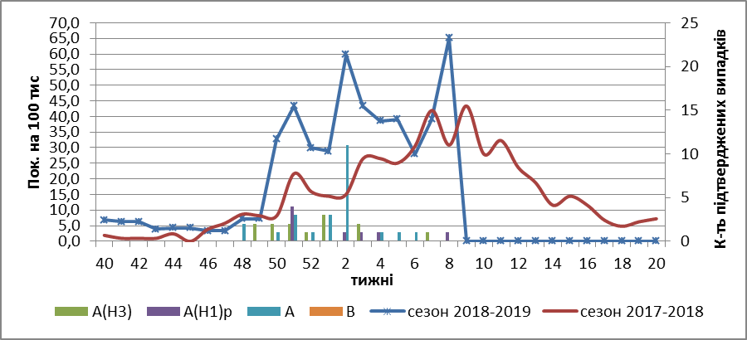

Fig.1. The dynamic of recorded ILI cases and number of laboratory confirmed influenza cases in 4 sentinel centers of Ukraine in the 2018 – 2019 season.

During the 8th week in 10 hospitals of 4 sentinel centers there were hospitalized 1215 patients, this is 1.5% less than during the previous week. The quantity of SARI patients (patients which meet the definition SARI) was 38 cases (1.25 per 100 thousand). This is twice more than the morbidity index of previous week. Laboratory confirmed 2 influenza A(H1)pdm viruses (fig. 2).

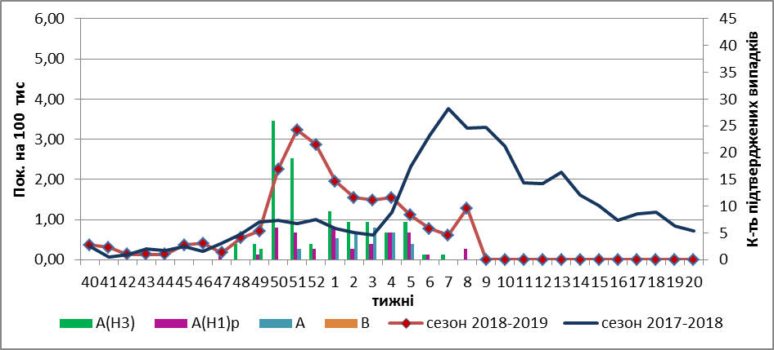
Fig.2 The dynamic of recorded SARI cases and the number of laboratory confirmed influenza in season 2018 – 2019 in four sentinel centers of Ukraine.

The percentage of SARI from all hospitalized was 3.1% (fig. 3).
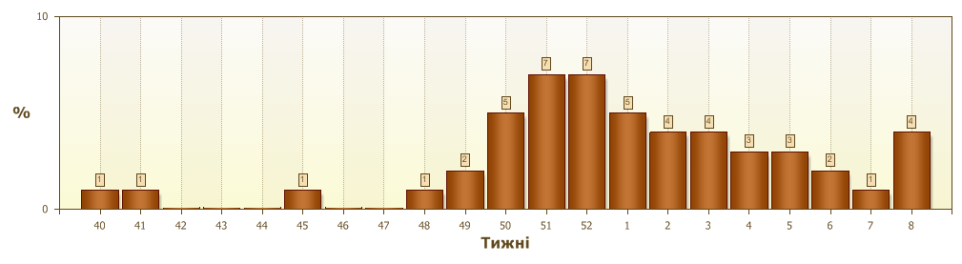
Fig.3. Proportion of SARI from the total number of hospitalizations.

From the beginning of the season 2018-2019 there were investigated 445 samples from ILI and SARI patients by PCR method. Laboratory confirmed 254 (57.0%) influenza positive cases: 124 (48.8%) - A(H3), 52 (20.5%) – influenza A(H1)pdm viruses and 78 (30.7%) – influenza A (unsubtyped) (fig. 4).

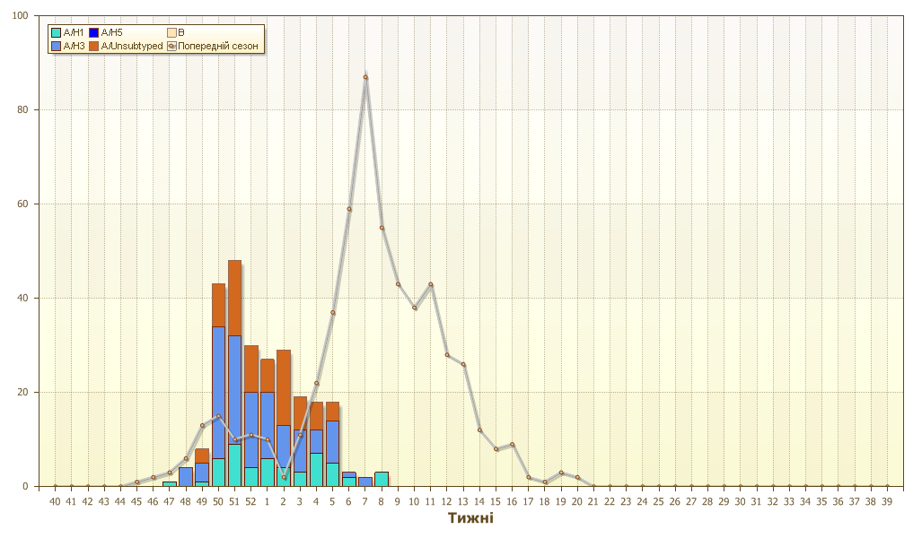
Fig.4. Number of laboratory confirmed influenza positive cases in sentinel centers of Ukraine.

Performed by:
Alla Mironenko, MD, DSc
Olga Holubka, PhD

