L.V. Gromashevsky Institute of Epidemiology and Infectious Diseases National Academy of Medical Science of Ukraine

Scientific Influenza and ARI Center

Weekly Bulletin for Influenza Epidemic Situation in Ukraine by 4 Sentinel Centers
(Кyiv, Dnipro, Odessa, Khmelnitsky)
Week 9, 2018

Loaded on website www.ukrinfluenza.com.ua

Since 2008 the system of ILI and SARI sentinel surveillance has been functioning in Ukraine. The sentinel centers are located in different geographical areas of the country: in Kyiv, Dnipro, Odessa and Khmelnytsky, which include 18 sentinel stations: 10 hospitals and 8 polyclinics.
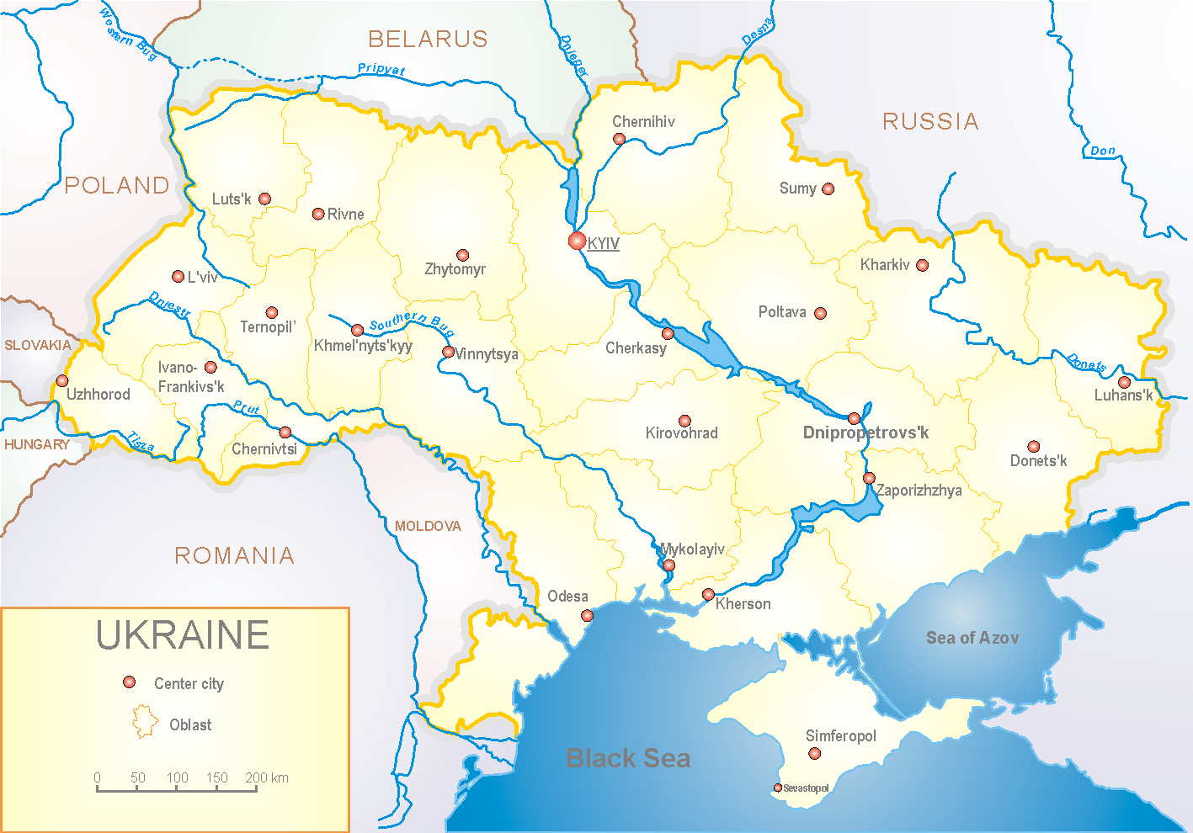
In 8 policlinics of 4 sentinel cities of Ukraine the quantity of outpatient, which meet the definition of ILI during the 9th week (26.02 – 04.03.18) was 90 cases (43.4 per 100 thousand) corresponding population. In comparison with the previous week the growth rate of morbidity levels was 40.6% (fig. 1).

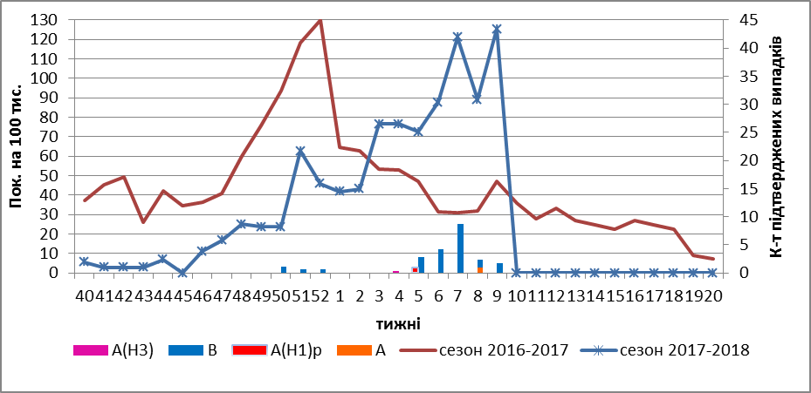
Fig.1. Dynamic of ILI cases and number of laboratory confirmed influenza cases in 4 sentinel centers of Ukraine in the 2017 – 2018 season.
The reason of significant growth rate during this week is the returning children to study after necessary holidays.
During the 9th week 2018 in 10 hospitals of 4 sentinel centers there were hospitalized 1225 patients, this is 12.75% less than during the previous week. The quantity of SARI patients (patients which meet the definition SARI) was 98 cases (3.3 per 100 thousand); the growth rate of morbidity levels was 1% in comparison with the previous week (fig. 2).

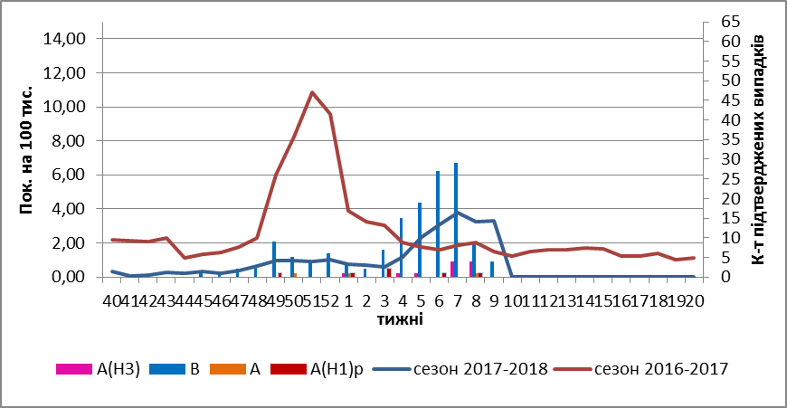
Fig.2 The dynamic of SARI cases and the number of laboratory confirmed influenza in season 2017 – 2018 in four sentinel centers of Ukraine.

From 40th to 9th week 2017-2018 there were investigated 634 samples from ILI and SARI patients by PCR method. From the beginning of season there were laboratory confirmed: 4 - influenza virus A (unsubtyped), 7 – influenza virus A(H1)pdm, 12 – A(H3), 181 – influenza viruses B, 19 – B/Yamagata, 41 – B/Victoria (fig. 3).

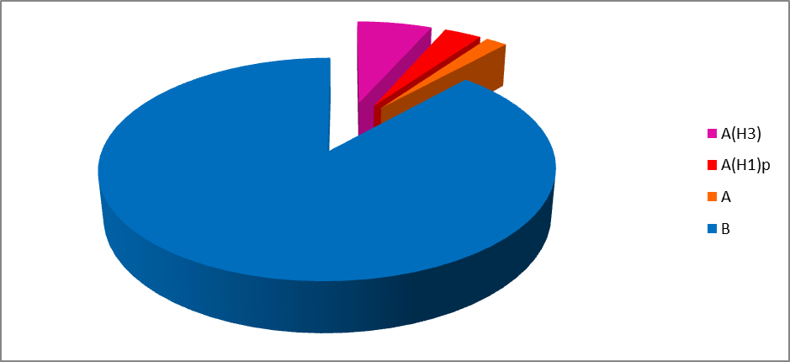
Fig.3 Etiologic structure of influenza viruses’ population in season 2017-2018 according to PCR results in four sentinel centers of Ukraine.

So ILI and SARI indexes of morbidity in 4 sentinel centers match seasonal levels. The circulation of influenza virus B prevails.

Performed by:
Alla Mironenko, MD, DSc
Olga Onyshchenko, PhD

