L.V. Gromashevsky Institute of Epidemiology and Infectious Diseases National Academy of Medical Science of Ukraine

Scientific Influenza and ARI Center

Weekly Bulletin for Influenza Epidemic Situation in Ukraine by 4 Sentinel Centers
(Кyiv, Dnipro, Odessa, Khmelnitsky)
Weeks 9, 2019

Loaded on website www.ukrinfluenza.com.ua

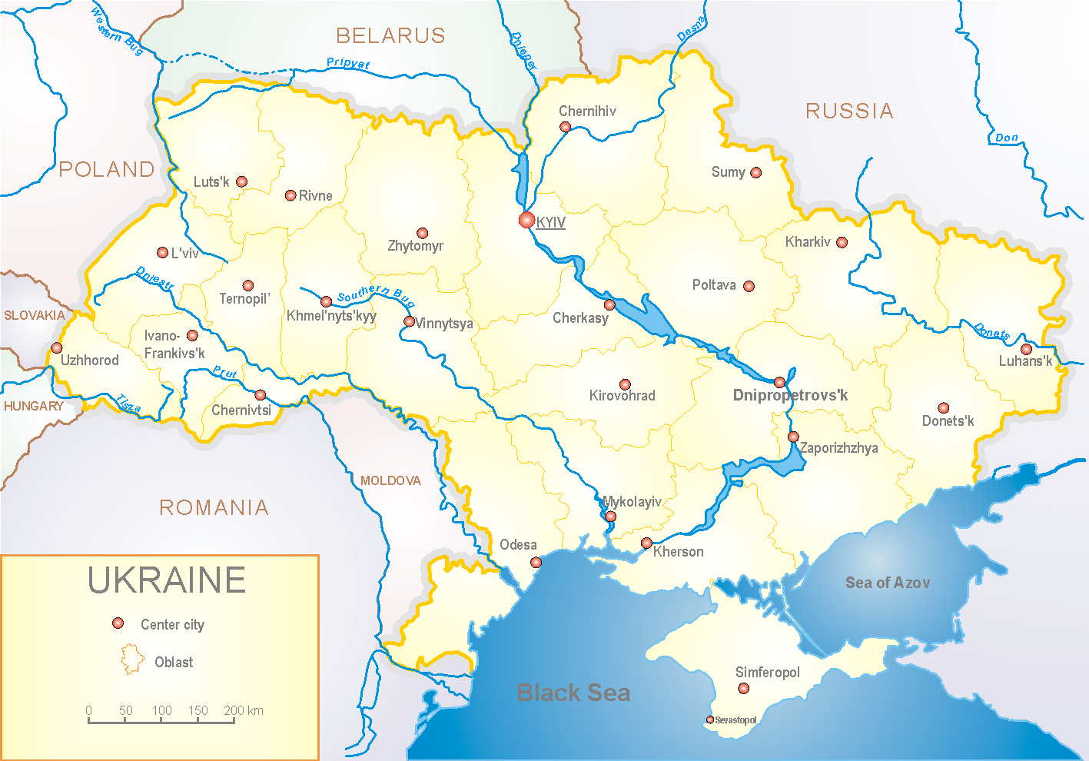
Since 2008 the system of ILI and SARI sentinel surveillance has been functioning in Ukraine. The sentinel centers are located in different geographical areas of the country: in Kyiv, Dnipro, Odessa and Khmelnytsky, which include 18 sentinel stations: 10 hospitals and 8 polyclinics.

According to data of influenza sentinel surveillance system in Ukraine in 8 policlinics of 4 sentinel centers the quantity of outpatients, which meet the definition of ILI during the 9th week (25.02.19 – 03.03.19) was 105 cases (50.6 per 100 thousand). The decrease of morbidity level was 22.2% (fig 1).

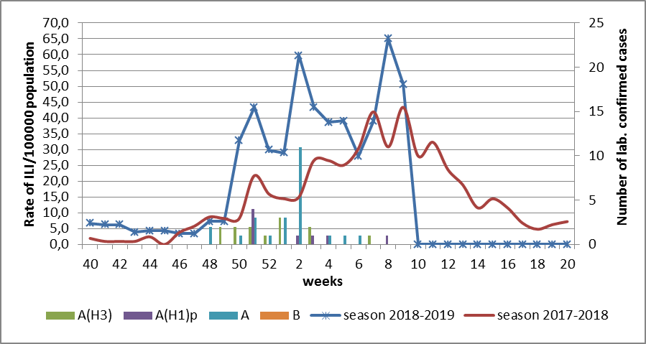

Fig.1. The dynamic of recorded ILI cases and number of laboratory confirmed influenza cases in 4 sentinel centers of Ukraine in the 2018 – 2019 season.

During the 9th week in 10 hospitals of 4 sentinel centers there were hospitalized 1230 patients, this is 1.2% more than during the previous week. The quantity of SARI patients (patients which meet the definition SARI) was 26 cases (0.88 per 100 thousand). The decrease of morbidity level was 31.6%. 1 influenza A virus (unsubtyped) was laboratory confirmed (fig. 2).

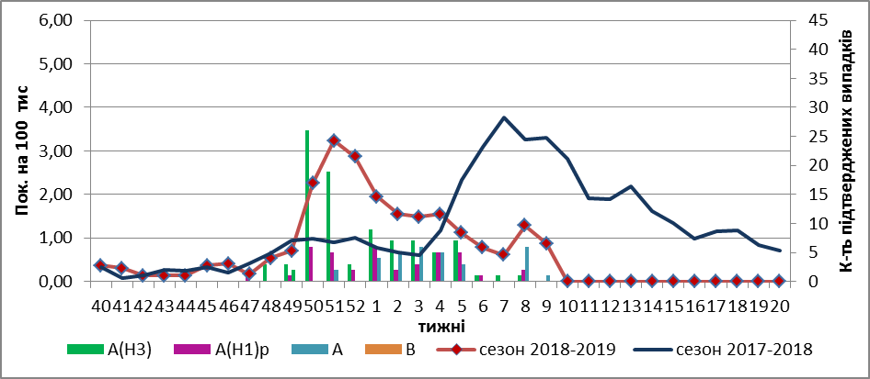
Fig.2 The dynamic of recorded SARI cases and the number of laboratory confirmed influenza in season 2018 – 2019 in four sentinel centers of Ukraine.

The percentage of SARI from all hospitalized was 2.1% (fig. 3).
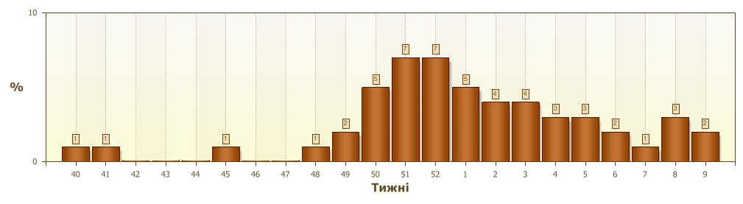
Fig.3. Proportion of SARI from the total number of hospitalizations.

From the beginning of the season 2018-2019 there were investigated 521 samples from ILI and SARI patients by PCR method. Laboratory confirmed 305 (58.5%) influenza positive cases: 128 (42%) - A(H3), 52 (17%) – influenza A(H1)pdm viruses and 125 (41%) – influenza A (unsubtyped) (fig. 4).

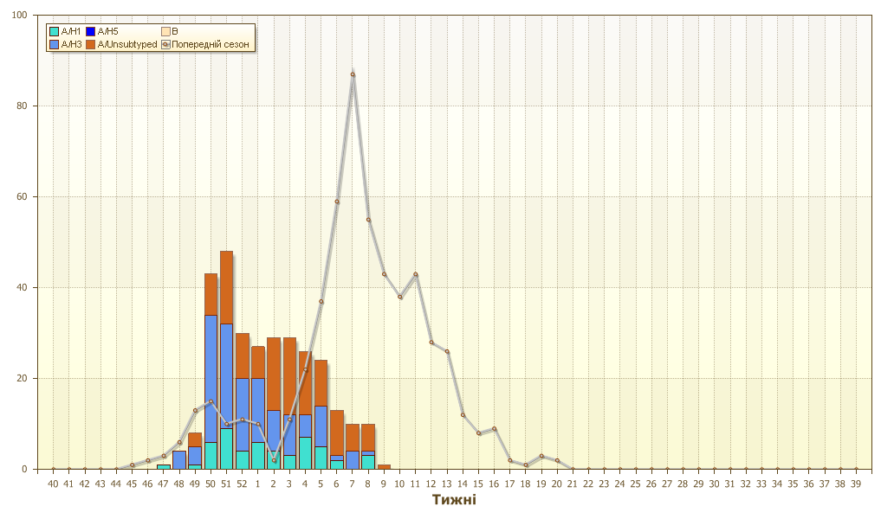
Fig.4. Number of laboratory confirmed influenza positive cases in sentinel centers of Ukraine.

Performed by:
Alla Mironenko, MD, DSc
Olga Holubka, PhD

